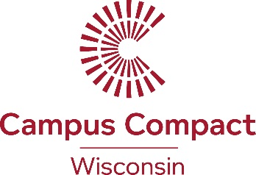

FOR IMMEDIATE RELEASE

Cardinal Stritch University and UW Madison Staff Receive Awards for Civic Engagement

Every year, Wisconsin Campus Compact (WiCC) recognizes faculty and staff from Wisconsin colleges and universities who go above and beyond to bring the community into the classroom and to make their campuses more engaged in the community. This year, two faculty will be recognized on March 8 at UW-Whitewater with the Sister Joel Read Civic Engagement Practitioners Award: Sean Lybeck-Smoak from Cardinal Stritch University and Molly Schwebach from UW Madison. “Sean and Molly’s work exemplify what it means to be staff from universities and colleges who strive to make learning applicable to the real-world, while making higher education more relevant,” says WiCC Executive Director Gavin Luter. “Giving them this award is an honor and hopefully inspires other higher education professionals to think differently about their work.”

Awardee Information
Schwebach is a Senior Outreach Specialist with dual appointments at UW Madison’s Center for Healthy Minds and the Nelson Institute. Her extensive career in boundary-spanning roles at UW Madison demonstrates tireless devotion to fostering and facilitating community involvement for faculty, staff, and students. She has played a significant role in institutionalizing high quality civic engagement through graduate and undergraduate academic programs and curriculum, and in coordinating community events, in partnership with staff colleagues.
Lybeck-Smoak, the Director of Experiential Learning and Career Education at Milwaukee’s Cardinal Stritch University, has been a leader and the institutional glue for experiential learning, civic engagement, and community partnerships. During his 15-year tenure, Lybeck-Smoak has been steadfast in his commitment to building lasting community relationships, leveraging limited resources, and engendering trust and goodwill among everyone he serves. He has enabled countless students, faculty, and staff members to benefit from an array of high impact learning practices that ultimately have enhanced the value of a Stritch education as a whole.
About Campus Compact

Campus Compact is a national coalition of nearly 1,100 colleges and universities committed to the public purposes of higher education. In 2002, Wisconsin joined National Campus Compact’s movement toward an institutionalized commitment of civic engagement and service-learning. Learn more about the Wisconsin Campus Compact at http://www.wicampuscompact.org/. Awards were selected by a committee of community partners. The Sister Joel Read Civic Engagement Practitioners Award celebrates the legacy of Alverno College’s Sister Joel Read, president of the college for 25 years.

Contact:
Gavin Luter
gavin@compact.org
608-839-7331

